**Description**

As a user, I must have ability to enter in Login or Register.

------------------------------------------------------------------------------------------------------------------------------------------

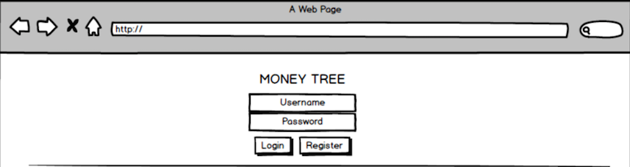

**Acceptance criteria**

* Displays Login page
* Options to login if they are a returning user or create a new account
* If a **NEW** user types in a username and password and Hits the login button, they should receive a notification that the account was not found because they have not created a new account yet.
* Displays Sign in button.
* May display option to recover forgotten password.